**Software Requirements Specification**

Mystery Trivia

**Authored by:**

Mohammed Chokr

Austin Jeffery

Jason Marrone

Mohammed Rubel

# Document Approval

The following document has been accepted and approved by the following:

| **Signature** | **Printed Name** | **Title** | **Date** |
| --- | --- | --- | --- |
|  | Mohammed Chokr | Back-end Lead | 2/13/2023 |
|  | Austin Jeffery | Team Lead | 2/13/2023 |
|  | Jason Marrone | Front-end Lead | 2/13/2023 |
|  | Mohammed Rubel | Documentation Lead | 2/13/2023 |

**Table of Contents**

**Revision History** **2**

**Document Approval** **2**

**1. Introduction** **5**

1.1 Purpose 5

1.2 Scope 5

1.3 Definitions, Acronyms, and Abbreviations 5

1.4 References 7

1.5 Overview 7

**2. General Description** **7**

2.1 Product Perspective 8

2.2 Product Functions 8

2.3 User Characteristics 8

2.4 General Constraints 8

2.5 Assumptions and Dependencies 9

**3. Specific Requirements** **9**

3.1 External Interface Requirements 9

3.1.1 User Interfaces 9

3.1.1.1 Web Page View 10

3.1.1.2 Login View 11

3.1.1.3 Register View 12

3.1.1.4 Category View 13

3.1.1.5 Maze View 14

3.1.2 Hardware Interfaces 15

3.1.3 Software Interfaces 15

3.1.4 Communications Interfaces 15

3.2 Functional Requirements 16

3.3 Non-Functional Requirements 35

3.3.1 Security 35

3.3.2 Reliability 36

3.3.3 Usability 36

3.3.4 Availability 37

3.4 Design Constraints 38

3.4.1 Hardware Constraints 38

3.4.2 Software Constraints 38

3.5 Logical Database Requirements 38

3.6 Other Requirements 38

**4. Analysis Models** **39**

4.1 Data Flow Diagrams (DFD) 39

# 

# 

# 

# 

# 

# 

# 

# 

# 

# **1. Introduction**

## **1.1 Purpose**

This Software Requirements Specification (SRS) document provides a detailed description of the features, functionalities, and non-functionalities of Mystery Trivia. The document will provide a comprehensive description of the user interface and will serve as a blueprint for the development and implementation of the software. This document will cover software, hardware, and other technical dependencies.

## **1.2 Scope**

The scope of the project includes the development of a two-dimensional maze game on a webpage. The game will feature new generated maps with varying difficulty levels that the users will control an object to navigate through the maze while answering questions. Users will be able to interact with the object throughout the maze using their keyboard. Users will be able to click on the screen to choose their answers. The game will have a variety of questions based on the users’ chosen category such as Math, History, English. Users will be able to use points to help make progress throughout levels. There will be additional bonus chests that will help players gain points which will allow one of the options that is not the answer to be crossed out. There will be a login implemented to keep track of user data using a PlayFab database which will also keep track of the players points. This application will be used by boys and girls and will be able to use it by going to the game website. This software is to target children who want to enjoy learning while having fun

The game will not have an online multiplayer feature where players can compete with each other. There will be no score board to keep track of who answered the questions faster or who has the highest score. This game will not have more than three categories. The game will not allow creation of categories. The application will not have multiple languages or a translator, everything will be in plain english text.

## **1.3 Definitions, Acronyms, and Abbreviations**

| **Term** | **Definition** |
| --- | --- |
| User | A person who is going to interact/use the application. |
| Web-Browser | A web browser is a software program that allows a user to locate, access, and display web pages. |
| Web-Application | The game will be on a website where users will be able to interact with. |
| PlayFab | A database hosting service backed by Microsoft. This database will be used for this project. |
| Inputfield | A set of text where a user has to enter. |
| Category | A grouping of topics based on the subject. |
| Scene | A scene is what holds the game objects together. |
| Maze | A network of paths designed as a puzzle through which the user has to find their way. |
| Enemy | A hostile opponent who is against the player. |
| Chest | An object containing a reward for touching it. |
| Points | A number that keeps track of the rewards earned. |
| Start | A position where the user will begin. |
| End | A position where the user will end to advance to the next level. |
| Levels | When completing the maze the player will advance to a more difficult maze which will result in being in a higher level. |
| Database | A place where user information will be stored and brought back. |
| Walls | This is an object that will prevent players from cutting through paths. |
| Questions | A sentence where the player is asked about the selected subject. |
| Answers | A response to the question asked. |
| Play as Guest | This allows users to play the game without logging in or registering |
| Missing | Something that is not there and needs to be added |

## **1.4 References**

Microsoft. (n.d.).  *Usage and limits | PlayFab*. Microsoft. February 8, 2023, from https://learn.microsoft.com/en-us/gaming/playfab/personas/bi

Microsoft. (n.d.). *What is PlayFab? | PlayFab*. Microsoft. February 8, 2023, from https://learn.microsoft.com/en-us/gaming/playfab/what-is-playfab

Technologies, U. (n.d.). *Unity user manual 2021.3 (LTS)*. Unity. February 8, 2023, from https://docs.unity3d.com/Manual/index.html

## **1.5 Overview**

The rest of the document will cover three additional chapters which will explain in detail how the software works and what each implemented feature will do. The second chapter will provide a general description of the product, functions, user characteristics, intended audience, and constraints.

The third chapter provides the requirements specifications in detailed terms and description of the different system interfaces such as user and external interface. This chapter will include hardware, software, communication, and all the functional requirements that will be met.

In addition, this chapter will include a list of functional requirements that must be met by the system. These requirements specify the specific actions and tasks that the system must be capable of performing, such as data input, processing, storage, and retrieval. User interactions with the system, such as displaying of information, and other output.

The fourth chapter will include a data flow diagram to clearly define the inputs, outputs, and the flow of data between different components of the system. The data flow diagram will provide a comprehensive view of how the system is designed and the interactions with external systems. The data flow diagram will ensure that the system is designed and implemented in an efficient and effective manner.

# **2. General Description**

This product is a Maze Game that contains simple Math, History, and English questions that occur when the user progresses throughout the game. In addition, the target audience will ensure that this product is simple and easy-to-use. This also means that simple words and obvious designs will be implemented to ensure an optimal product.

## **2.1 Product Perspective**

In comparison to other projects, this project provides a unique way of teaching by fostering engagement through games. There are other related projects that are shown on various educational websites, where there are various interactive questions in each game. However, very few games do not resemble a maze, they resemble racing, fighting, and cooking games. Furthermore, of the very few games that have a maze design, this unique game offers users a chance to dodge enemies and open new levels by asking challenging questions. It’s a challenging game that requires a great deal of analysis from the user.

## **2.2 Product Functions**

This software tool provides an educational and interactive opportunity for young kids to improve their skills in Math, History, and English. In hopes of making learning fun, the goal is to ensure that young kids have a fun way of learning and processing information, and at the same time, using that useful information in their future.

## **2.3 User Characteristics**

The general characteristics of the users are young kids seeking to hone their skills in reading, History, Math, and English. The software does not target the older generation, so consequently, the software pertains to a simpler design. Furthermore, the software has good UI/UX to ensure the young users understand and navigate through the game. In addition, the software tool directs its attention towards kids who are in the early stages of learning towards Math, History, and English. As a result, the questions are very beginner level, but they tend to get harder as the user progresses throughout the game.

## **2.4 General Constraints**

Some of the general constraints are the budget and the time for the project. Due to being short on time, the development team will use free assets such as free sprites and background images. If the team were given a budget they would be able to purchase nicer looking assets that would affect the design of the game.

## 

## **2.5 Assumptions and Dependencies**

It is assumed that the user is familiar with an internet browser and can use the keyboard and mouse to navigate through the webpage and play through the game. It will also be assumed that the user will have an internet connection to stay connected since it is on a webpage. It will also be assumed that there will not be a large user base otherwise that would require the database to have more storage.

# **3. Specific Requirements**

This section contains all the functional and non-functional requirements of the system. It will give more details about each feature in the requirements table.

## **3.1 External Interface Requirements**

### **3.1.1 User Interfaces**

The system will consist of a website with a unity embed that allows users to create accounts, log in, view scores, and play the game. Additional web pages will be present for contact, controls, and about information. The user will be able to navigate through the website by going to the homepage, where the game will be displayed, how to play, where the user will get information for controls, about us, where the user will be able to learn more about the developers of this project, contact us, where the users will be able to email the developers. Within the website is where our game will be. Our game is the majority of the project as it will be a maze game for users to play and learn their chosen category.

### **3.1.1.1 Web Page View**

The web page view will be the layout of the website design. There will be a homepage where the user will have access to play the game. There will also be a how to play page that will tell the player what the controls are and what to do and avoid throughout the game. Third there is a about us page that will explain who the developers are. Lastly there will be a contact us page that will let the users submit a form that will email whichever developer they want to contact.

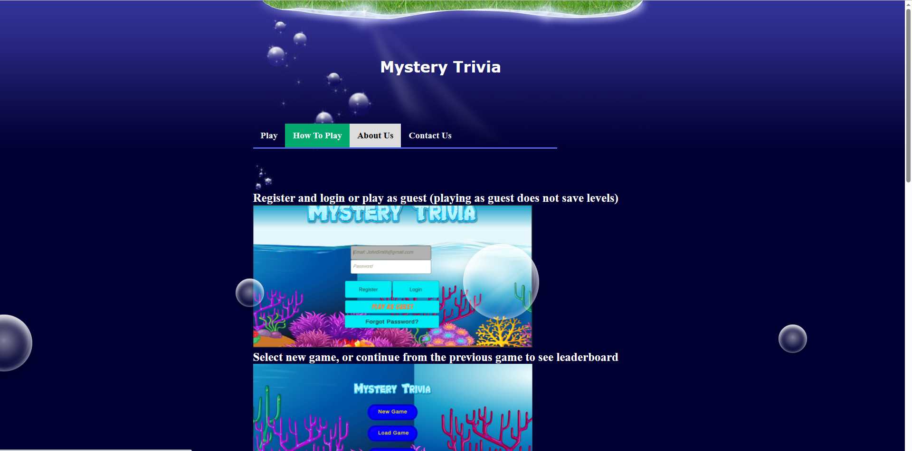

### **3.1.1.2 Login View**

The login view will show the input text fields within the Mystery Trivia game where a user can enter their email and password to login to their account. The user’s information is kept within the PlayFab database. The database will also store the player’s hint points, as well as the level that they are on. After the user enters their login information it will lead them back to the maze, so they can continue their playthrough. If a user does not have an account already in the database, they can create one by clicking on the register button.

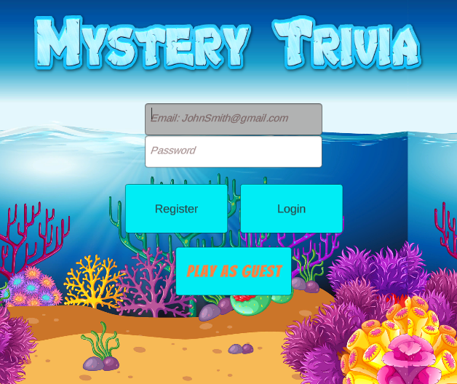

### **3.1.1.3 Register View**

The register view will show the text input fields where a user can enter their email, username, and password. They must enter the same password for it to register. After the user has entered valid values, they can register their account and it will be saved to the PlayFab database.

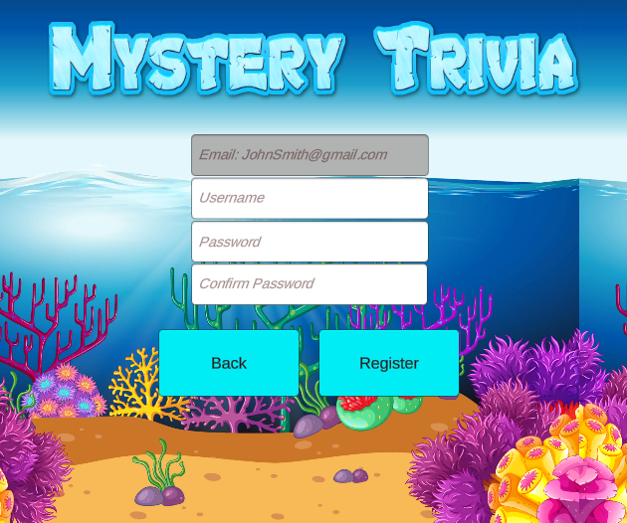

### **3.1.1.4 Category View**

Once a user has logged in they will be presented to the category view. The category view is where a user can select which category of questions they will want to answer within the maze game. There are three current categories being Math, History, and English. After a user has selected a category they will then start the maze game at level one.

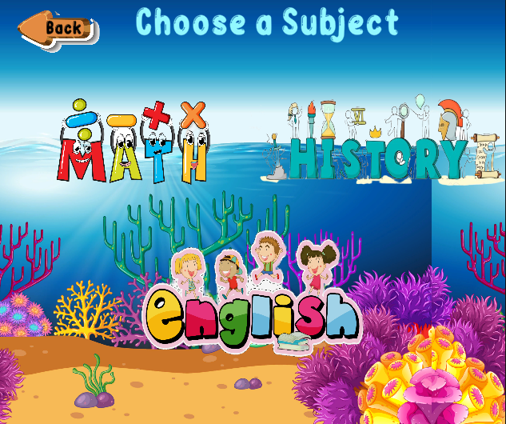

### **3.1.1.5 Maze View**

Once the user has selected the category that they want their questions in, they will start in the maze game at level one. The player must navigate through the maze and avoid the enemies otherwise they will be sent back to the beginning. There are various locks that may block the path of the player, and only answering the question correctly will allow them to pass through. There will also be chests within the game that may give the player hint points upon opening.

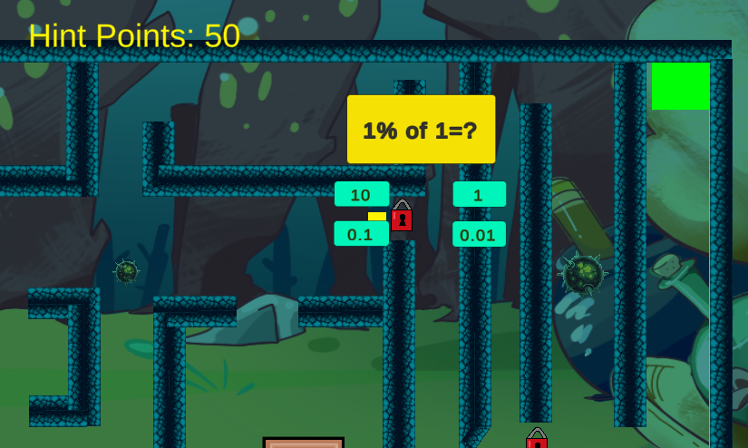

### 

### 

### 

### 

### 

### 

### 

### **3.1.2 Hardware Interfaces**

The mystery trivia game uses the standard hardware for typical computer applications, namely a computer, monitor, mouse, and keyboard. Specialized hardware is not necessary for this application.

### **3.1.3 Software Interfaces**

The mystery trivia game relies on a unity player embedded within a webpage. A standard web browser and operating system will be sufficient for the application. Any additional programs beyond a web browser are unnecessary. Additional software used to interface with web browsers may be used at the user’s discretion.

*Popular web browsers used by the public.*

### **3.1.4 Communications Interfaces**

The system will implement the https protocol to ensure that communications are secure between all endpoints. Testing will use local copies of the software; a certified host will be necessary for commercialization.

## **3.2 Functional Requirements**

| Title | Registration (high) |
| --- | --- |
| ID | FR1 |
| Requirement | The system should allow users to create an account. |
| Description | When the user enters the website, they will see a register button which they can click and register their information to create an account. |
| Input | The user will fill out fields to enter their email, username, password, and confirm password. |
| Processing | User’s email, username, and password will be sent to check whether it is valid data such as the passwords are the same and that the email is not already registered. If it is valid it will continue through PlayFab authentication where it will store the new users data. |
| Output | Upon successful registration, the user will then be shown the login menu where they will have to re enter their login information. |
| Dependencies | None |
| Error Handling | Failure to provide valid email or empty values for password and username will provide an error message that will be displayed to the user telling them what is wrong. |

| Title | Login (high) |
| --- | --- |
| ID | FR2 |
| Requirement | The system will allow users to log into the application. |
| Description | The user will be able to login and access a profile with stored data. |
| Input | The user will enter their email and password. |
| Processing | The users’ input fields will check to see if they are valid and within the database. |
| Output | The user will be logged into the application. The user will then be displayed the play menu screen, where the user can start a new game, continue from where they last left off, or select a difficulty and start ahead. |
| Dependencies | FR1 |
| Error Handling | Failure to give valid login information will display an error message telling them what is wrong. For example, if they entered a valid email but the wrong password the message will display “Wrong password”. |

| Title | Reset Password (medium) |
| --- | --- |
| ID | FR3 |
| Requirement | The system will allow for a user to reset their password. |
| Description | The user should be able to reset their lost or forgotten password by email by clicking the reset password button. |
| Input | Email |
| Processing | The database will check whether that email is already registered, if it is PlayFab will send an email to that registered user. |
| Output | Password reset sent to email, link to help them change password. |
| Dependencies | FR1 |
| Error Handling | If the user entered an invalid email, an error message will be displayed telling them the email is not already registered. |

| Title | Wrong Answer (medium) |
| --- | --- |
| ID | FR4 |
| Requirement | If the user selected a wrong answer, the system will show them it is wrong. |
| Description | The user will have to give an answer to continue with the maze and if they click the wrong answer they will not be able to move on, they get unlimited tries but will not receive full points if they get the answer wrong the first time. |
| Input | Selection of the incorrect answer on the question view. |
| Processing | The selected answer will check to see if that value is the correct answer. If it is wrong it will lower the amount of points available for the next attempt. |
| Output | If the answer is wrong, it will appear red and the question will disappear and allow for the user to try again. |
| Dependencies | FR11 |
| Error Handling | None |

| Title | Difficulty level (low) |
| --- | --- |
| ID | FR5 |
| Requirement | The software will have levels of difficulty toward ages 8-12. |
| Description | Users of eight to twelve years of age will be able to complete the application. Level one will have difficulty questions geared toward ages 8-9. Level two will have difficulty questions geared to 9-10, level three will be 10-11 and level 4 will be 11-12. As the level increases, so will the maze length and difficulty. |
| Input | N/A |
| Processing | N/A |
| Output | N/A |
| Dependencies | None |
| Error Handling | N/A |

| Title | Getting Hint Points (medium) |
| --- | --- |
| ID | FR6 |
| Requirement | The system will allow for a user to acquire hint points. |
| Description | While the user is playing through the maze they will have to answer questions. Answering questions will initially grant 50 hint points. |
| Input | A correct answer will be selected on the question screen. |
| Processing | The hint point counter will be incremented. |
| Output | The hint point counter will display the new value. |
| Dependencies | FR4 |
| Error Handling | If there is an error the hint point counter will not change. |

| Title | Spending Hint Points (medium) |
| --- | --- |
| ID | FR7 |
| Requirement | The software will enable users to spend hint points. |
| Description | With a sufficient amount of hint points acquired, the user will be able to select a hint button that removes a single wrong answer. |
| Input | The hint button will be selected. |
| Processing | The application will check to see if the user possesses enough points for a hint. |
| Output | One of the incorrect answers will not be able to be selected from the choices available. |
| Dependencies | FR4, FR6 |
| Error Handling | If the user does not have enough points for a hint, an appropriate error message will be presented. No hint points will be deducted. |

| Title | Movement (medium) |
| --- | --- |
| ID | FR8 |
| Requirement | Ability to move the player throughout the maze. |
| Description | The player character will respond to user input. The arrow keys will decide where to move the character. For example, if the character pressed both up and right arrow keys the character would move up and right at the same time. |
| Input | The user will press one of the arrow keys. |
| Processing | The system will record the arrow key pressed and the duration of the press. |
| Output | The player character will have moved to a new position based on the arrow key pressed and the duration of the press.. |
| Dependencies | None |
| Error Handling | If there is an issue with the input the player character will remain motionless. |

| Title | Mouse interaction (medium) |
| --- | --- |
| ID | FR9 |
| Requirement | Ability to click on categories and in game objects. |
| Description | The game will respond to mouse input on appropriate objects. |
| Input | The user will click on an interface element. |
| Processing | Whichever button they click on will carry out that function. |
| Output | The system will have entered a new state. |
| Dependencies | None |
| Error Handling | None |

| Title | Question answering (high) |
| --- | --- |
| ID | FR10 |
| Requirement | The system shall allow users to answer questions |
| Description | The user will be able to use the mouse to select an answer from the answers provided. |
| Input | The user will click on an answer while the question view is active. |
| Processing | Based on the answer chosen it will check to see if that value is correct. Once it checks it will send back whether it is the correct answer by displaying green for the background of the button, or red if the answer was wrong. |
| Output | The question will display the answer chosen and have either red or green background if it was correct or not. |
| Dependencies | FR9 |
| Error Handling | If there is an error with processing the system will revert to its initial state. The pop up question will close. |

| Title | Enemy behavior (medium) |
| --- | --- |
| ID | FR11 |
| Requirement | Enemies shall move in a regular pattern along a preset path. |
| Description | Enemies shall have predefined paths to strategically block certain areas of the maze. |
| Input | None |
| Processing | Enemies will refer to their preset paths to determine their next movement. |
| Output | Enemies will have an animation where they move across the maze. |
| Dependencies | None |
| Error Handling | If an enemy cannot access its movement path, it will stop. |

| Title | Player respawning (high) |
| --- | --- |
| ID | FR12 |
| Requirement | Upon death the player character will immediately respawn at the last spawn point. |
| Description | If the player character suffers death from enemy contact, they should immediately respawn at the last spawn point they contacted. |
| Input | Player collision with an enemy. |
| Processing | The hint point counter will change to the starting value they had at the start of the maze. |
| Output | The player character will be immediately instanced at the last spawn point. |
| Dependencies | FR8 |
| Error Handling | If the player character cannot respawn, the instance of the maze will reload. |

| Title | Level exit (high) |
| --- | --- |
| ID | FR13 |
| Requirement | The user shall be able to exit a maze by making physical contact with the end. |
| Description | All mazes within the application shall contain an end that will mark maze completion upon contact. |
| Input | The player character will make physical contact with the end. |
| Processing | The end scene will load. |
| Output | The application will display the end scene where it will tell them how many points they achieved and will display the next level after 3 seconds. |
| Dependencies | FR8 |
| Error Handling | If the level exit cannot load its scripts, it will instead do nothing. |

| Title | Chest Hint Points (low) |
| --- | --- |
| ID | FR14 |
| Requirement | The system shall allow the user to collect hint points upon interacting with chests. |
| Description | While the user is navigating through the maze, there will be chests available for the user to interact with. Upon reaching a chest it will grant the user 150 hint points. |
| Input | The player character shall make physical contact with a chest within the maze. |
| Processing | Set the value of hint points to equal the current plus the gained value. |
| Output | Hint points will be increased by 150. |
| Dependencies | FR8 |
| Error Handling | None |

| Title | Categories (medium) |
| --- | --- |
| ID | FR15 |
| Requirement | The system shall allow categories the player can choose from. |
| Description | When the user first logs on, or is playing as a guest, they will have to choose a category that they want their questions to be in. There will be three categories to choose from, Math, English, and History. |
| Input | Player mouse movement and clicking. |
| Processing | Upon choosing the Math category it will set the category value to Math, so the player will get questions based on Math. |
| Output | The questions will be the chosen category and will display those questions through the maze. |
| Dependencies | FR2 |
| Error Handling | None. |

| Title | Starting Difficulty (low) |
| --- | --- |
| ID | FR16 |
| Requirement | The system shall allow users to select a starting difficulty. |
| Description | When the user logs on to their account for the first time, they will be able to select the starting difficulty which will allow them to skip the easier levels and questions. |
| Input | Player mouse movement and clicking. |
| Processing | Set the player level value to whichever value they choose. |
| Output | Depending on the difficulty chosen, they will start on a harder maze level along with harder questions. Level 1 is for ages 8-9, level 2 is for ages 9-10, level 3 is for 10-11, and level 4 is for 11-12. |
| Dependencies | FR2 |
| Error Handling | If the user tries to enter an invalid level an error message will be displayed asking them to input a valid value. |

| Title | Sound Settings (medium) |
| --- | --- |
| ID | FR17 |
| Requirement | The system shall allow users to change the sound settings. |
| Description | There will be sound through the game. There will be background music and sound effects that the user will be able to toggle how loud they want to hear those effects.There will be an option to change the volume of music, and sound effects where the user can click and drag how loud they want the sound to be. |
| Input | User selection of the audio element via mouse input. |
| Processing | Upon moving the selected values, it will change that sound value. |
| Output | The audio level will change based on the audio element. |
| Dependencies | FR9 |
| Error Handling | It will only allow for a minimum set value and a maximum value and nothing beyond that scope. |

| Title | Tab Select (low) |
| --- | --- |
| ID | FR18 |
| Requirement | The system shall allow using the tab key to go down on selected input text fields and buttons. |
| Description | When on the main menu of the login screen, the user may press tab to go down to the next field to enter their input. |
| Input | Player keyboard tab key. |
| Processing | If the user presses the tab key, it will select the next input field as if they clicked on it. |
| Output | The selected text field or button will change to the next one or lower option. |
| Dependencies | None |
| Error Handling | If the function does not work there will be no change. |

| Title | Shift Tab Select (low) |
| --- | --- |
| ID | FR19 |
| Requirement | The system shall allow using the combination of shift plus tab keys to go up on selected input text fields and buttons. |
| Description | When on the main menu of the login screen, the user may press shift + tab to go up to the next field to enter their input. |
| Input | The user shall press shift and tab simultaneously on their keyboard. |
| Processing | When shift and tab are pressed together, it will act as if a mouse clicked on the previous input field. |
| Output | The selected text field or button will change to the previous one or higher option. |
| Dependencies | None |
| Error Handling | If the function does not work there will be no change. |

## 

## 

## 

## 

## **3.3 Non-Functional Requirements**

### 3.3.1 Security

| Title | Secure User Data (high) |
| --- | --- |
| ID | NFR1 |
| Requirement | The system shall ensure that user data is secure. |
| Description | When the user logs on to their account, their data must be secured and impenetrable for hackers to steal. |
| Input | User enters data in login fields |
| Output | User data is registered on PlayFab |
| Dependencies | None |

| Title | Data Authentication (high) |
| --- | --- |
| ID | NFR2 |
| Requirement | The system shall allow for authentication of the login credentials |
| Description | When the user logins to the system, the username and password must be checked with the data in PlayFab for successful login. |
| Input | User data sent to the PlayFab |
| Output | Authenticated data sent back |
| Dependencies | None |

### 3.3.2 Reliability

| Title | Full Functionality (high) |
| --- | --- |
| ID | NFR3 |
| Requirement | System requires all components to work effectively. |
| Description | All components of the game are working functionally. The game, the login page, and the authentication. |
| Input | User using the game online |
| Output | User enjoys the game and is happy playing the Mystery Trivia |
| Dependencies | NFR1, NFR4 |

### 3.3.3 Usability

| Title | User Interface (high) |
| --- | --- |
| ID | NFR4 |
| Requirement | The system shall allow ease of user experience |
| Description | The user should be able to find the help that they need and have no troubles in using the web app. The webpage and maze game should be easy to navigate through menus such that an eight year old will be able to use. |
| Input | Website development. |
| Output | Great UI/UX for the User to navigate. |
| Dependencies | None |

| Title | Response to User Input (medium) |
| --- | --- |
| ID | NFR5 |
| Requirement | The system shall allow for immediate response to user input |
| Description | As the user plays through the maze game, the system should respond to any input within a tenth of a second. This will allow for the player to move the character instantly and not have delayed movement. |
| Input | User keyboard |
| Output | Game display. |
| Dependencies | NFR1 |

| Title | Responsive Website (high) |
| --- | --- |
| ID | NFR6 |
| Requirement | The system shall allow for the website to be responsive. |
| Description | Since not all screens are the same, the webpage must be responsive so it will allow for any dimensions. |
| Input | Window dimensions |
| Output | Display screen |
| Dependencies | None |

### 3.3.4 Availability

| Title | Uptime (medium) |
| --- | --- |
| ID | NFR7 |
| Requirement | The system shall maintain availability all the time. |
| Description | The webpage must be available for users to play at any time of the day. |
| Input | None |
| Output | Website |
| Dependencies | NFR1 |

## **3.4 Design Constraints**

### **3.4.1 Hardware Constraints**

Not applicable to this project.

### **3.4.2 Software Constraints**

This project will be using Unity as it is a free and easy to learn game engine. The user's computer must have internet access and a web browser such as Google Chrome to be able to load the website and the game. This project will be using Visual Studio as the IDE for creating and editing scripts within Unity.

## **3.5 Logical Database Requirements**

PlayFab will be used as the back-end service that allows for quick, scalable data where it will store the users information such as email, name, password, and points that they have. All management will be done on the PlayFab platform to handle all the users data. The database server is using the free option package so it can hold up to 1 gigabyte. The database will also be able to do 50,000 document reads per day and 20,000 writes per day.

## **3.6 Other Requirements**

* If the game errors, the team will be notified immediately of the crash
* Any bugs or glitches will require immediate notification to the team

# **4. Analysis Models**

List all analysis models used in developing specific requirements previously given in this SRS. Each model should include an introduction and a narrative description. Furthermore, each model should be traceable to the SRS’s requirements.

## **4.1 Data Flow Diagrams (DFD)**

Ements. The data flow diagram will represent how the data will be distributed throughout the project. This includes the layout of the game as to when the user creates an account to when a user finishes a maze. More closer up images will follow after this image.

